HOW TO USE THE GARBAGE DISPOSAL
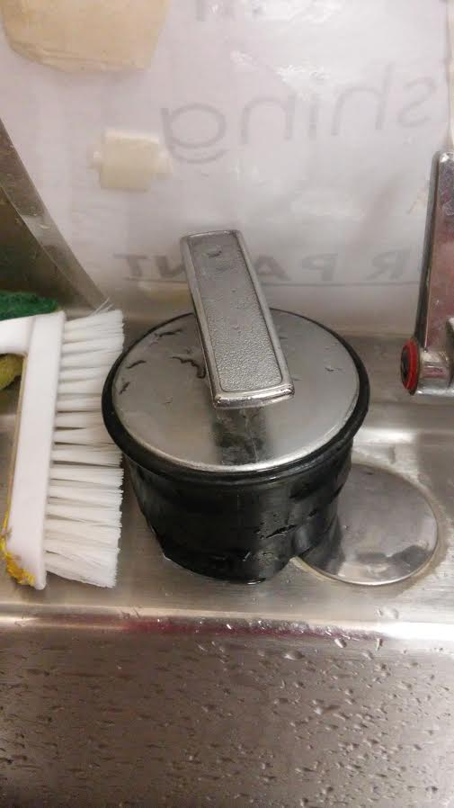
Step one: Place the cork from the image to the left into the disposal
Step Two: turn on the water
Step Three: turn on the disposal on the left wall next to the sink/paper towels
Step four: rotate the cork until it makes noise (that is how you know it’s working!)
Step five: wait a few second, then turn off and remove cork.

