BYU Idaho Child Development Laboratories
Toddler Lab, Clarke 202 Fire Escape Plan
- When the fire alarm rings, teachers and children will exit out of the west toddler lab emergency exit door straight down the access ramp to the west stairs. They will then go right down the stairs and proceed straight to the grassy quad between the Clarke and Romney buildings.
- One teacher should grab the emergency backpack while the other teachers and children walk outside, not waiting to pick up coats or any other belongings.
- If the weather is cold, one teacher should get children’s coats out of their lockers and then meet the other teachers at the designated meeting place on the grassy quad.
- Once the children and teachers have exited the building, the Faculty Supervisor will make sure all the children and teachers are out of the classroom. (Check under and behind furniture, and in the restrooms.) The Faculty Supervisor will be the last person to exit the classroom.
- As soon as the children and teachers are gathered together on the grassy quad, the Lead Teacher should count all the children and teachers present.
- The class will wait on the grassy quad until it is determined if it is safe or not to return to the building.
- The class will not enter the building until authorized by Campus Police or the Madison County Fire Department.
- If the building cannot be reentered, children and teachers will congregated in the Smith foyer and families will be called to pick up their children from that location.
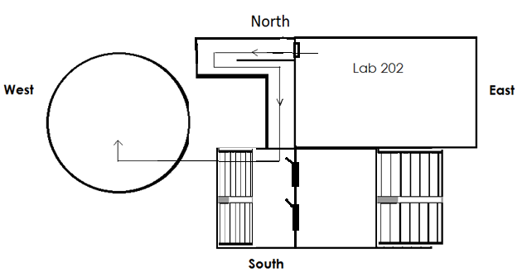
- Child Authorized pick-up lists and a sign-out sheet will be used for all children being picked up.

Secondary Escape Plan
In the rare event that the ramp is blocked or inaccessible, exit out the east toddler classroom door, and go right down the west stairs to outside, then continue down the stairs to the grassy quad between the Clarke and the Romney buildings.

In Case of Emergency
Fire Extinguisher is located in the preschool kitchen
Campus Police 496-3000

BYU Idaho Child Development Laboratories
Toddler Lab, Clarke 269 Fire Escape Plan
- When the fire alarm rings, teachers and children will exit out of the west toddler lab door, turn left and go down the short hallway to the emergency exit door of the building. From here they will go right, down the access ramp to the west stairs, they will then go right down the stairs and proceed straight to the grassy quad between the Clarke and Romney buildings.
- One teacher should grab the emergency backpack while the other teachers and children walk outside, not waiting to pick up coats or any other belongings.
- If the weather is cold, one teacher should get children’s coats out of their lockers and then meet the other teachers at the designated meeting place on the grassy quad.
- Once the children and teachers have exited the building, the Faculty Supervisor will make sure all the children and teachers are out of the classroom. (Check under and behind furniture, and in the restrooms.) The Faculty Supervisor will be the last person to exit the classroom.
- As soon as the children and teachers are gathered together on the grassy quad, the Lead Teacher should count all the children and teachers present.
- The class will wait on the grassy quad until it is determined if it is safe or not to return to the building.
- The class will not enter the building until authorized by Campus Police or the Madison County Fire Department.
- If the building cannot be reentered, children and teachers will congregated in the Smith foyer and families will be called to pick up their children from that location.
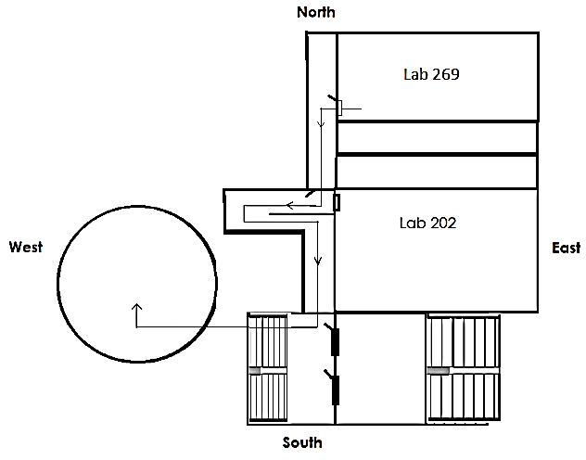
- Child Authorized pick-up lists and a sign-out sheet will be used for all children being picked up.

Secondary Escape Plan
In the rare event that the ramp is blocked or inaccessible, exit out the east toddler classroom door, and go right down the hallway and then right again down the west stairs to outside, then continue down the stairs to the grassy quad between the Clarke and the Romney buildings.

In Case of Emergency
Fire Extinguisher is located in the preschool kitchen
Campus Police 496-3000

