BYU-Idaho Child Development Laboratories Emergency Escape Plan

- When a fire alarm rings, all preschool labs will exit out of the south preschool lab doors into the south playground.
- Children should walk outside not waiting to pick up coats or other belongings.
- If the weather is cold, one teacher should get children’s coats out of their lockers and then meet other teachers at the designated meeting place (see below) on the playground.
- The supervisor will gather the roll, class roster, emergency backpack, a cell phone and check to make sure all children are out of the room (check under and behind furniture and in the restrooms). The supervisor will be the last person to exit the classroom.
- As soon as the children are gathered together on the playground, the lead teacher should count all of the children present.
- Once children and teachers have exited the building, the lab director and faculty advisor with each lab will confirm that no children are missing.
- Do not enter the building until authorized by Campus Police or Madison County Fire Department.
- If the building cannot be re-entered, children and teachers will exit the playground out of the gates to the Smith Building foyer.

Designated Meeting Places
West Lab—Sandbox
East Lab—Log Fort
North Lab—Willow House

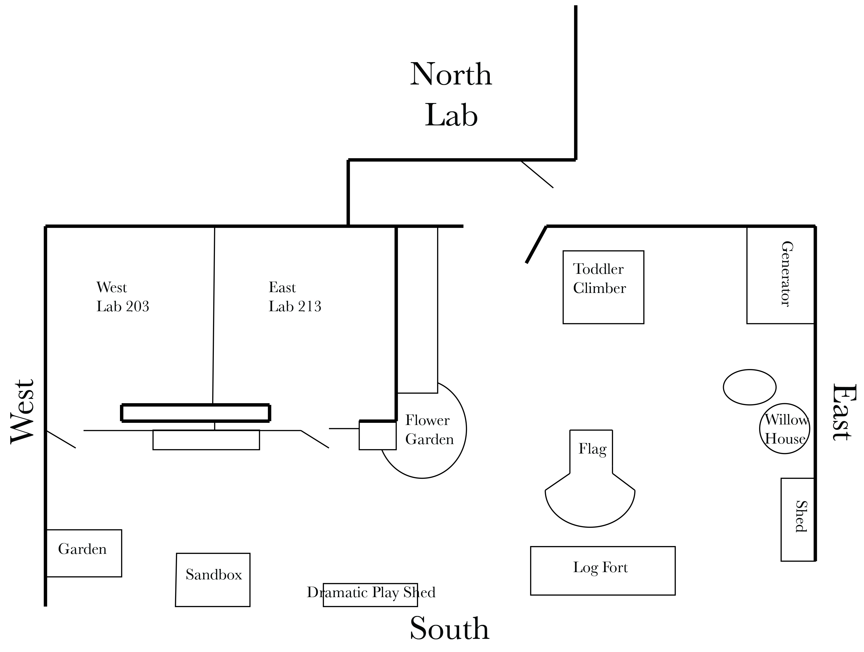

Secondary Escape Plan
In the rare event the playground doors are locked or it is unsafe on the playground, then East and West Labs will exit through the hallway doors and then exit the building through the east doors, towards the parking lot and turn left to congregate on the North playground.

In Case of Emergency
Fire extinguisher is located in the preschool kitchen.
Campus Police 496-3000

